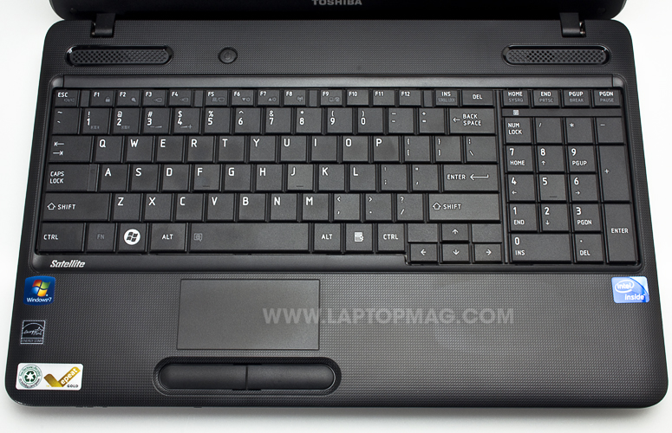

Toshiba Satellite C655-S5542